Experiment 9: Perform Rotation of an Image in Clockwise and Counter Clockwise Direction
Aim
To perform image rotation in both clockwise and counter-clockwise directions using Python and OpenCV.
Software Requirements
- Python 3.x
- OpenCV (cv2)
- Visual Studio Code / PyCharm / Jupyter Notebook
Procedure
- Install the OpenCV library using pip install opencv-python.
- Import the OpenCV library.
- Read the input image using cv2.imread().
- Check whether the image is loaded successfully.
- Rotate the image 90° clockwise using cv2.rotate().
- Rotate the image 90° counter-clockwise using cv2.rotate().
- Display the original, clockwise rotated, and counter-clockwise rotated images.
- Press any key to close all image windows.
Python Code
import cv2
# Read the image
image = cv2.imread("sample.jpeg")
if image is None:
print("Error: Image not found!")
else:
# Rotate 90 degrees clockwise
rotated_image = cv2.rotate(image, cv2.ROTATE_90_CLOCKWISE)
# Display images
cv2.imshow("Original Image", image)
cv2.imshow("90 Degree Clockwise Rotation", rotated_image)
cv2.waitKey(0)
cv2.destroyAllWindows()
Output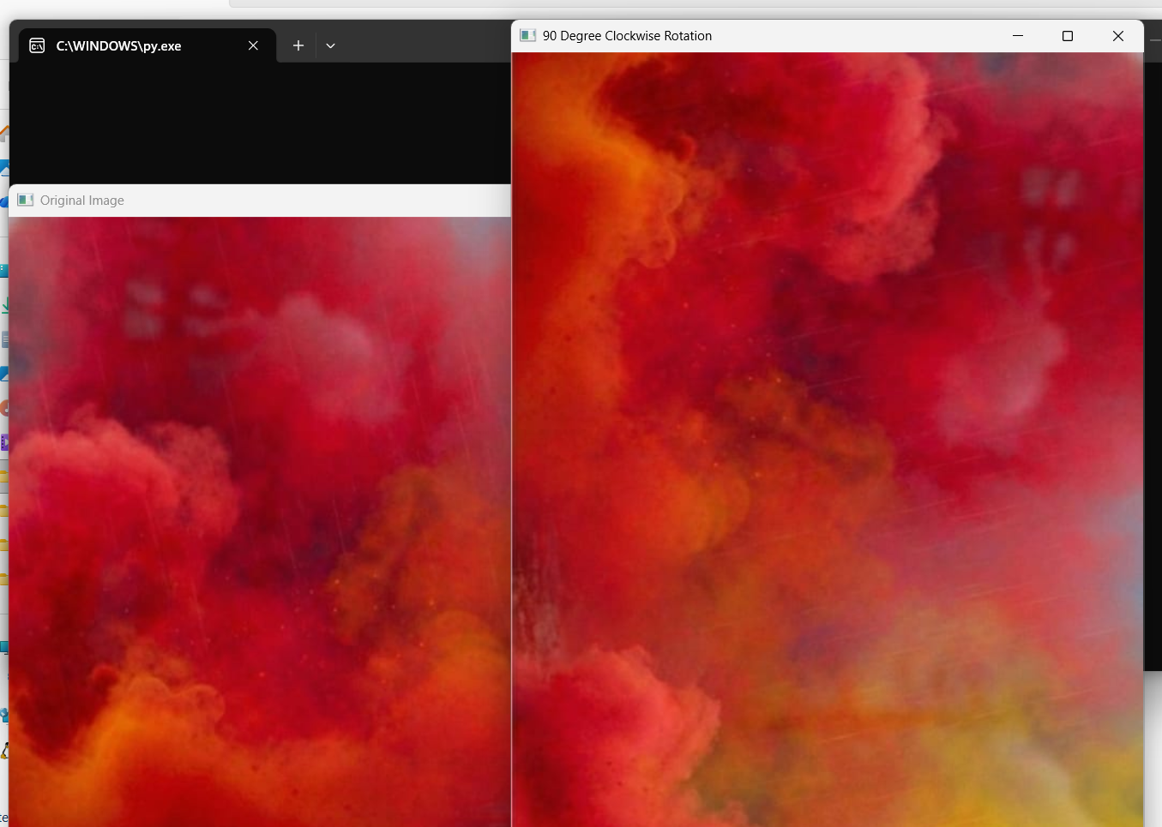
Result
The input image was successfully rotated in both clockwise (90°) and counter-clockwise (90°) directions using Python and OpenCV. The rotated images were displayed successfully.

